October Newsletter  Problem Solving & Constructed Responses We are using the Singapore Bar Model Drawing strategy when we solve problems in the math lab. This strategy forces the students to slow down and really think about what the story problem is asking, gives them a quick visual of the problem, and helps them check to see if their answer is reasonable. I have just started exposing 1st grade to this method and have not used it with kindergarten at all.  We either solve a story problem or write about the problem we solved the previous time every time the students come to the math lab. We have a graphic organizer we use to help us write a constructed response about problem solving. I send home the problem which has the Bar Model Drawing strategy on the handout and the constructed response graphic organizer. We use the organizer to help us write the response on the tables using dry erase markers which the students enjoy doing and it saves on paper usage. Kindergarten and first grade are not doing constructed responses in the math lab right now.  If your child is in 2nd grade are above, there is a program on www.mathplayground.com called “Thinking Blocks” that we have done together in class and would be great practice for problem solving using the bar model drawing method.  If your child is in 4th or 5th grade and wants a challenge, have them go to my blog and go to the “problem solving” posts that I do for Math Olympiad. They are very challenging and engaging!  Amanda.lovett@cobbk12.org www.livelearnlovett.weebly.com  Math Lab Focus  Number Sense · Basic Fact Strategies · Problem Solving · Written Responses |  |  | What is going on in the lab? Visit my blog to see pictures and a summary of what we are doing in the lab each week. www.livelearnlovett.weebly.com/blog  Conference Week  Visit my bulletin board during conference week for a handout for your child’s grade level(s). The bulletin board is right outside the lunchroom.  Wish List  Dry Erase Markers  Erasers  Pencils  Game Supplies: Pawns/Dice/Spinners/Timers from old games that you are throwing out. (Things that can be used for games we play in Math Lab)  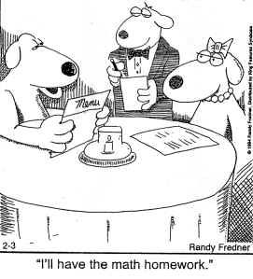  Contact Info  www.livelearnlovett.weebly.com  Amanda.lovett@cobbk12.org  Room 410

